IDXBroker Sample Ideas to post on Facebook
If you need assistance with finding the correct URL for any of the ideas below, shoot us an email to support@yoursiteneedsme.com and we will do our best to help!

    - IDEAS & Topics: The first thing you want to do is come up with some ideas that your audience might engage new buyers or sellers. We have come up with a bunch to help you get started but once you get the hang of it you will probably find all kinds of new ways to use this method to get leads. Create a word document and copy these and any others you can think of into that document and keep a list of them handy so you can use them anytime!
      - Your Company Agent Site: Post your Company Agent site to your audience and tell them they can search all properties through your site. Make sure you let them know that your site is more accurate than Trulia & Zillow and the other big nationwide sites out there because your site is directly connected to your local MLS and is updated daily. FACT: Most people that search Zillow & Trulia DON’T KNOW that they are not updated directly from the MLS and are frustrated when they get outdated listings and results. Polls say they would use a different site if they knew one that was reliable and accurate. YOUR site is reliable AND accurate. Tell EVERYONE! [http://yourname.yourcompanyurl.com]
      - Advanced Property Search: Customize your own search to pick out features in a home that your want! Want a home with a pool? How about a waterfront home? Or a home with a 2 car garage? Put in all of your most wanted features and customize your home search to fit your dream home! [IDXAdvancedSearchURL + ?agentHeaderID=123456]
      - Hot Property Alerts: FACT: The most desirable homes typically sell within DAYS of being listed! Make sure you are set up to be alerted when a new home comes on the market by setting up Property Alerts now! [IDXEmailUpdateSignupURL + ?agentHeaderID=123456]
      - Map Search: use our interactive Map Search to draw the boundaries around the area or areas you want to find a home in. You can even narrow it down by price, beds, baths & more! [IDXMapSearchURL + ?agentHeaderID=123456]
      - Free Home Valuation: Find your homes Current Market Value! Tell us a little bit about your home and we will run a FREE No Obligation CMA on your home that will tell you what your homes value is in todays’ real estate market. [IDXHomeValuationURL + ?agentHeaderID=123456]
    - Custom Examples: You can see how using the standard pages can be a valuable way to get leads. But there are even more options than that! All you need to do is go to metroroberts.com and use the search pages to make a custom search and then add your Agent ID to the end of the URL - then copy it into a Facebook Post! For example:
      - Property of the Day: Do a search and pick ANY property and go to the listing detail page for that property, copy the URL and add your Agent Header ID to the end. [IDXCustomSearchURL + &agentHeaderID=123456]
      - Today’s NEW LlSTINGS: Want to know what’s hot? Click here to see the newest properties listed in the last 24 hours! [IDXCustomSearchURL + &agentHeaderID=123456]
      - This weeks Open Houses: Find out what homes are holding Open Houses this week so you can plan on viewing them! [IDXCustomSearchURL + &agentHeaderID=123456]
      - Community of the Week: View available homes for sale in [Subdivision]! This beautiful gated community has over 200 homes in it, has a club house, community pool & tennis courts with homes ranging between $XXX,XXX & $XXX,XXX. See what’s available today! [IDXCustomSearchURL + &agentHeaderID=123456]
      - Condo of the Day: Same as above but using [Condo] instead of [Subdivision]. [IDXCustomSearchURL + &agentHeaderID=123456]
      - Search Homes in [City]: Want to see what’s selling in [City]? Click here now to view available homes! [IDXCustomSearchURL + &agentHeaderID=123456]
      - Waterfront Homes: Summer is upon us! Now is the best time to pickup that vacation home you’ve been dreaming of! Click here to search homes for sale on [IDXCustomSearchURL + &agentHeaderID=123456]
      - MORE: The list goes on and on! You know what is popular in your area and it changes from season to season and year to year! Stay on top of these trends and use them to create custom searches that people will love and share with their friends!

SCROLL BELOW to find more info on the Best Times to Post to Facebook for Maximum Engagement!

Infographic by CoSchedule: https://coschedule.com/blog/best-times-to-post-on-social-media/

The best time to post to Facebook
by Hootsuite - https://blog.hootsuite.com/best-time-to-post-on-facebook-twitter-instagram/

Because of the complicated News Feed algorithm, getting your timing right on Facebook isn’t easy.
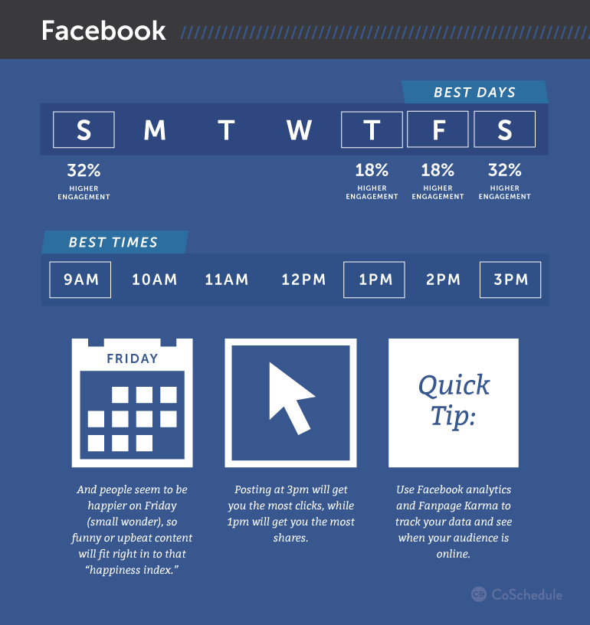
But despite the non-chronological functionality of the News Feed, our social marketing team has discovered publishing times that do indeed yield a higher amount of Likes, comments, shares, and click-throughs:
• The best time to post on Facebook is between 12 p.m. and 3 p.m. Monday, Wednesday, Thursday, and Friday.
• And on Saturday and Sunday between 12 p.m. and 1 p.m.
“For us, Tuesdays are a bit behind other weekdays in terms of Facebook engagement,” Hootsuite social media marketing specialist Amanda Wood explains. “But 12 p.m. to 3 p.m. is still the most effective window on that day.”
Hootsuite’s social team also sees lower engagement on the weekend, but there is a spike in click-throughs on posts published between 12 p.m. and 1 p.m.
Supporting these findings to a degree are Hubspot, Microsoft, and Quick Sprout. All three report the hours of 1 p.m. to 3 p.m. on Thursdays and Fridays are optimal posting times for Facebook.
As always, you should test and track results using engagement data gleaned from Facebook’s Page Insights, or other measurement tools such as Hootsuite Analytics to determine what works best for you.

